

**Energy Management System**

**Operation and Installation Manual**



**For Autel AC MaxiChargers EU**



This manual is intended to outline the Energy Management System Solution for Autel AC MaxiChargers EU. It describes the operating modes supported by the Autel Energy Management System, the installation instructions, and the app configuration.

**Revision Log**

|  |  |  |
| --- | --- | --- |
| **Version** | **Date** | **Rationale** |
| V1.0 | April 25, 2023 | Initial version |
| V1.1 | May 25, 2023 | Added a compatible energy meter. |

Trademarks

Autel® and MaxiCharger® are trademarks of Autel Intelligent Technology Corp., Ltd., registered in China, the Autel US Inc., and other countries. All other marks are trademarks or registered trademarks of their respective holders.

Copyright Information

No part of this manual may be reproduced, stored in a retrieval system or transmitted, in any form or by any means, electronic, mechanical, photocopying, recording, or otherwise without the prior written permission of Autel.

Disclaimer of Warranties and Limitation of Liabilities

All information, specifications and illustrations in this manual are based on the latest information available at the time of printing.

Autel reserves the right to make changes at any time without notice. While information of this manual has been carefully checked for accuracy, no guarantee is given for the completeness and correctness of the contents, including but not limited to the product specifications, functions, and illustrations.

Autel will not be liable for any direct, special, incidental, indirect damages or any economic consequential damages (including the loss of profits).

IMPORTANT

Before installing and operating the Autel Energy Management System, please read this manual carefully, paying extra attention to the important notes.

Services and Support

**Web:** [www.autelenergy.eu](file:///C:\Users\A21905\Desktop\www.autelenergy.eu)

**Tel:** +49 (0) 89 540299608 (Europe)

**Email:** support.eu@autel.com

For technical assistance in all other countries, please contact your local selling agent.

**CONTENTS**



|  |  |
| --- | --- |
| **1 Using This Manual** | / 01 |
| **2 Energy Management System** | / 02 |
| **3 DLB Mode** | / 06 |
| **3.1** **Installation Guide** | / 07 |
| **3.2** **Configuration** | / 08 |
| **4 ALM Mode w/ Single Charger** | / 16 |
| **4.1** **Installation Guide** | / 17 |
| **4.2 Configuration** | / 20 |
| **5 ALM Mode w/ Multiple Chargers** | / 27 |
| **5.1 Installation Guide** | / 28 |
| **5.2 Configuration** | / 28 |
| **6 PV Hybrid Mode** | / 37 |
| **6.1 Installation Guide** | / 38 |
| **6.2 Configuration** | / 38 |
| **7 Energy Management System Strategies** | / 45 |

# Using This Manual

This document describes how to use the Energy Management System and is intended for the following:

* Owners of Autel AC MaxiCharger products
* Certified electricians/installers

## Conventions

### Bold Text

Bold text is used to highlight selectable items such as buttons and menu options. Example:

* Tap **OK**.

### Notes

* **NOTE**: provides helpful information such as additional explanations, tips, and comments.
* **IMPORTANT**: reminds you that you must follow the instructions to prepare, set up, configure, and operate.

### Hyperlinks

Hyperlinks are available in electronic documents. Blue italic text indicates a selectable hyperlink, and blue underlined text indicates a website link or an email address link.

### Illustrations

Illustrations, especially the screenshots of the app interface, used in this document are for reference only. The actual product and screens may differ.

# Energy Management System

The Autel Energy Management System offers three operating modes. Each mode is described in more detail in the subsequent chapters. You can select a mode based on the different usage scenarios.

|  |
| --- |
| 1. **DLB Mode**   The purpose of DLB mode is to achieve the fastest charging by maximizing power efficiency for the power allocated to the chargers and keeping the system power within a specific range. |
| 1. **ALM Mode**   ALM mode provides consistent charging of chargers and other loads. The difference between ALM mode and DLB mode is that ALM mode manages load power and charger power at the same time using an external energy meter. |

|  |
| --- |
| 1. **PV Hybrid Mode**   PV Hybrid mode is achieved using solar energy. In PV Hybrid mode, renewable electricity will be prioritized for household loads, and the surplus renewable electricity will be provided for your charger to charge vehicles. When the surplus current is more than 6 A, your charger will be entirely powered by renewable electricity. When the renewable electricity is inadequate — the surplus renewable electricity is less than 6 A — the grid will provide extra power to meet the minimum current required by the charger. |

***Physical Devices Needed***

| **Operating Mode** | **Devices** |
| --- | --- |
| **DLB Mode** | * Autel AC MaxiCharger products * Router * Type A RCD or an equivalent electrical leakage protector * Ethernet cable |
| **ALM Mode w/ Single Charger** | * Autel AC MaxiCharger product * Energy meter * Type A RCD or an equivalent electrical leakage protector * RS485 cable |
| **ALM Mode w/ Multiple Chargers** | * Autel AC MaxiCharger products * Energy meter * Router * Type A RCD or an equivalent electrical leakage protector * Ethernet cable * RS485 cable |
| **PV Hybrid Mode** | * Autel AC MaxiCharger product * Energy meter * Type A RCD or an equivalent electrical leakage protector * RS485 cable * PV Panel * PV Inverter |

*General Features of the Operating Modes*

| **Item** | **DLB Mode** | **ALM Mode** | **PV Hybrid Mode** |
| --- | --- | --- | --- |
| **Primary Charger** | 1 | 1 | 1 |
| **Secondary Chargers** | 7 Max. | 7 Max. | N/A |
| **Communication Protocol Between Chargers** | Wi-Fi/Ethernet Cable | Wi-Fi/Ethernet Cable  (when using multiple chargers) | N/A |
| **Communication Protocol Between Primary Charger and Meter** | N/A | Modbus | Modbus |
| **Communication Method Between Primary Charger and Meter** | N/A | RS485 Cable | RS485 Cable |
| **Maximum Length of Ethernet Cable** | 100 m/328 ft | 100 m/328 ft  (when using multiple chargers) | N/A |
| **Maximum Length Between the Wiring of Primary Charger and Meter** | N/A | 200 m/656 ft | 200 m/656 ft |
| **Controller** | Autel Charge/Autel Config  (The operating mode runs when the configuration is set via app.)  **The Autel Charge app is used to illustrate the examples in this manual.**  Download the Autel Charge app by scanning the QR code below or directly from the Apple App Store or Google Play store, depending on the mobile device you are using. | | |

# DLB Mode

DLB mode is implemented when there are multiple chargers and no other loads share the power. To use DLB mode, ensure that all prerequisites are met according to the system diagram.

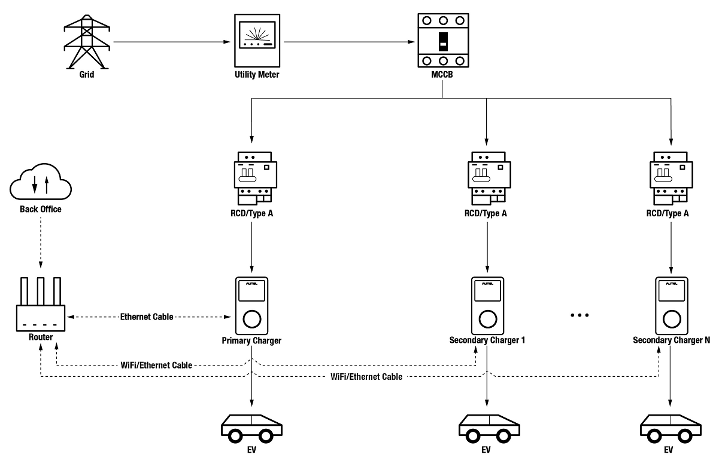

*DLB Mode System Diagram*

IMPORTANT

1. To comply with relevant electric leakage protection standards, please use at least a Type A RCD or an equivalent electrical leakage protector that complies with local standards.
2. Installation must be performed by qualified personnel in accordance with local regulations.
3. All chargers connected using DLB mode must be of the same model. (8 chargers at most in this mode.)

## Installation Guide

****

Both the primary charger and its secondary chargers need to be connected to the same LAN/WLAN:

1. The primary charger must establish a LAN/WLAN connection via an Ethernet cable.

|  |  |
| --- | --- |
| 1. Keep the power turned off during wiring. 2. Insert one end of the Ethernet cable with RJ45 plug into the RJ45 port on the charger.  * Put the Ethernet cable with RJ45 plug (**a**) through the nut (**b**) and the waterproof cap (**d**) (Leave some space between them.) * Connect the sealing ring (**c**) via its opening to the Ethernet cable and insert it into the waterproof cap. * Screw the nut into the waterproof cap and make sure they are securely fastened. * Insert the RJ45 plug of the Ethernet cable into the RJ45 port (**L**) on the bottom of the charger.  1. Insert the other end of the Ethernet cable with RJ45 plug into the RJ45 port on the router. | C:\Users\A20476\Desktop\Deta快引导图-7_画板 1.pngC:\Users\A20476\Desktop\Deta快引导图-8_画板 1.png |

1. Secondary chargers can connect to the LAN/WLAN via either Ethernet cables or Wi-Fi.
2. When connecting to the LAN/WLAN via Ethernet cables, the instructions are the same as that of the primary charger.
3. When connecting to the LAN/WLAN via Wi-Fi, refer to the **STEPS 1–4** in *3.2*.

## Configuration

Follow the steps below to activate DLB mode via the Autel Charge app once you have installed and wired all the units according to the system diagram.

1. **Download** the Autel Charge app.

**NOTE**

Make sure all Autel AC MaxiChargers and the Autel Charge app are running the latest software versions.

1. **Log in** to your Autel Charge app using your account and password, or register if you don’t yet have an Autel Charge account.

**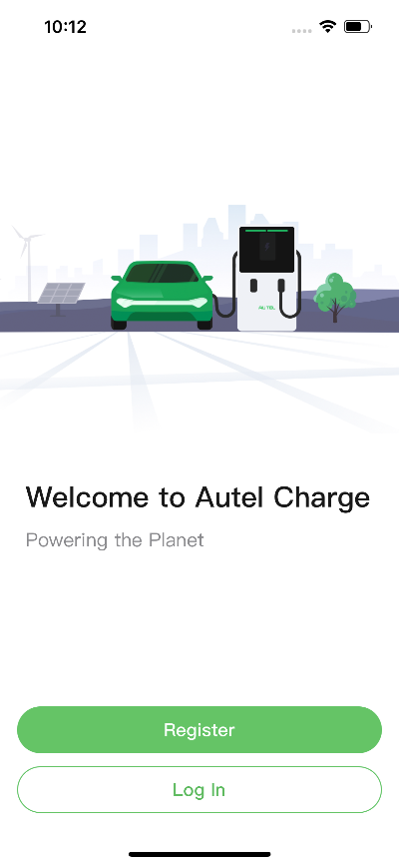 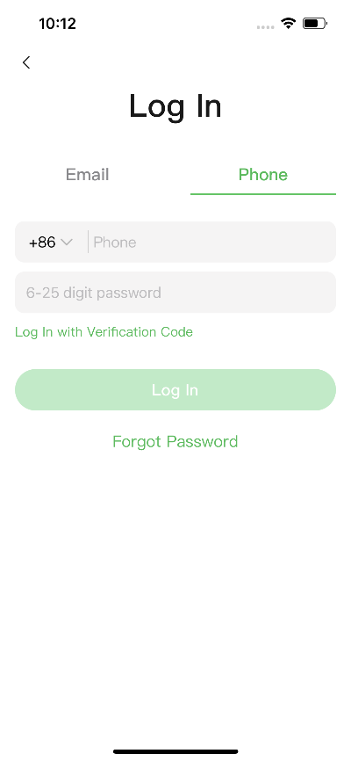**

1. **Add a charger.** After successfully logging in, tap **Add** to continue. Scan the QR code on the Quick Reference Guide to acquire the serial number and PIN of the charger, or tap **Enter Terminal Number** to manually enter the serial number and PIN. Tap **Link** after confirmation.

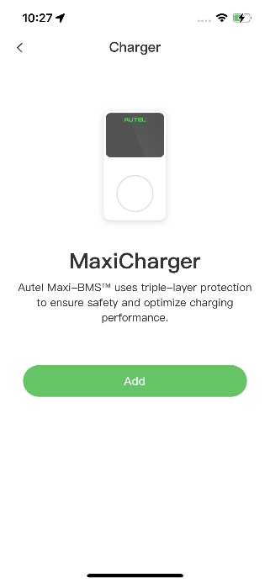 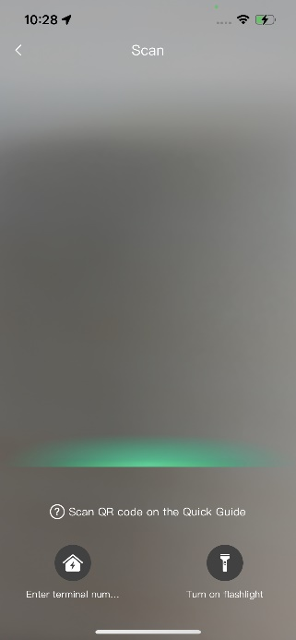 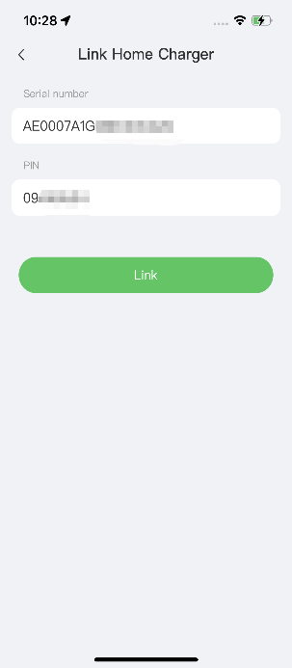

1. **Establish communication between the charger and the Autel Charge app.** After adding the charger, if you define the charger as the primary charger, tap **Connect via Bluetooth** to establish communication,then configure Wi-Fi for the charger. Tap **Completed** on the Charge Settings screen to proceed.

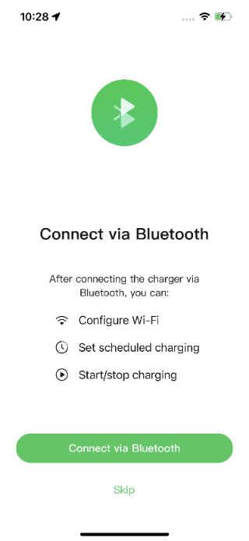 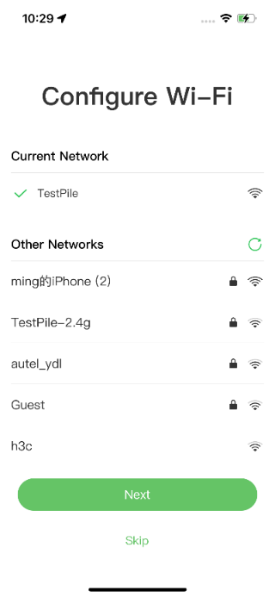 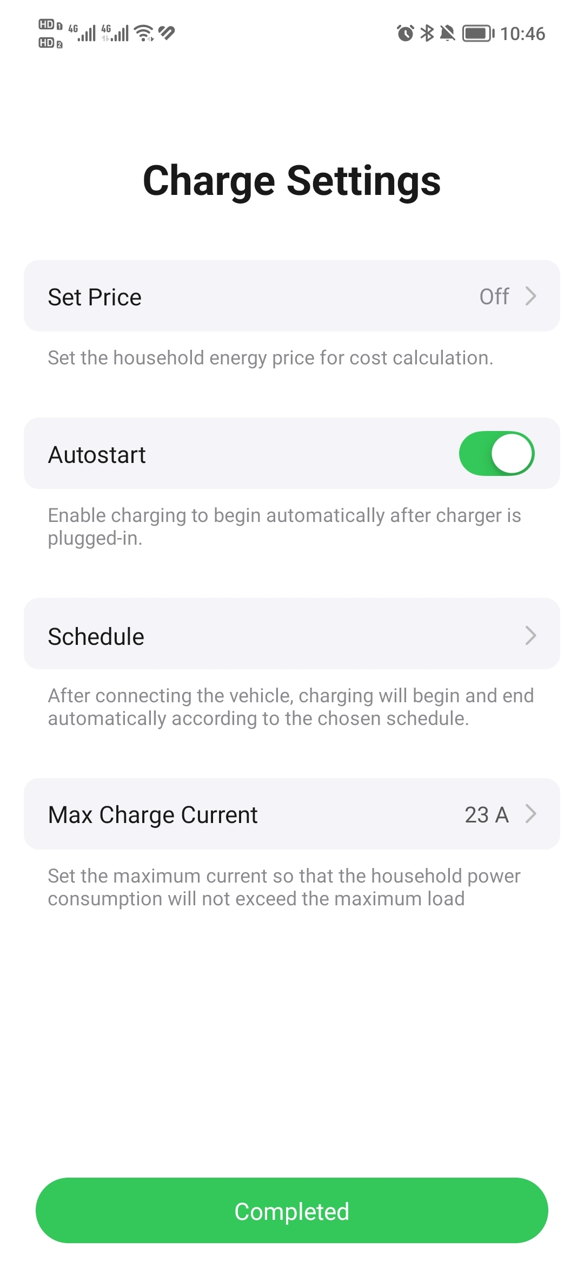

1. **Add secondary chargers.** Tap **Add** on the upper-right corner in the following screen and follow **STEPS 3–4** to add more chargers and configure their Wi-Fi.

**NOTE**

1. Bluetooth can only be connected to one charger at a time. Switching the operation to another charger will disconnect the Bluetooth connection with the existing charger and connect it to a new charger. Therefore, if you define the charger as a secondary charger, you need to tap **Skip** on the Connect Charger via Bluetooth screen, and configure Wi-Fi manually.
2. All chargers added must be on the same Wi-Fi network.

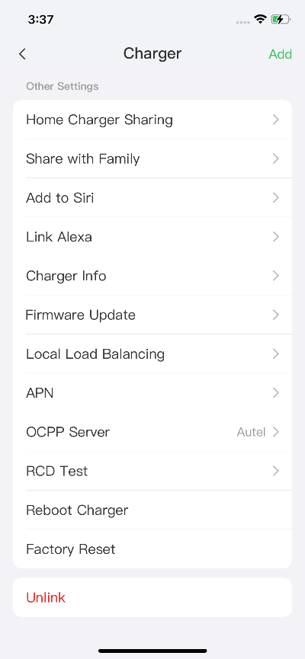

After adding chargers and configuring them to the same Wi-Fi network, you can check if the chargers are configured for smart charging by viewing the Internet Connection Indicator.

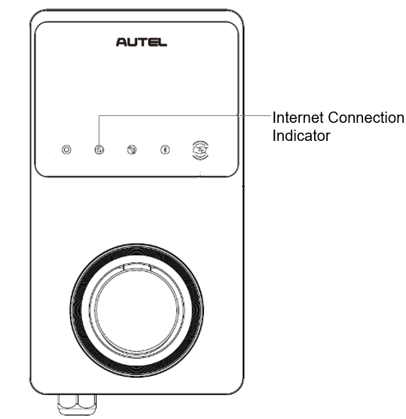

*Internet Connection Indicator*

| **Indicator** | **Status** | **Description** |
| --- | --- | --- |
| **Internet Connection Indicator** | Steady On | Network connected;  Smart charging not enabled. |
| Steady Off | Network not connected. |
| Blink Fast | Smart charging enabled;  Connection NORMAL. |
| Blink Slow | Smart charging enabled;  Connection ABNORMAL. |

1. **Set primary charger.** Tap **Account** ＞ **Charger** ＞ **Local Load Balancing**. Select **Power Sharing (Multiple)**. A brief description about this mode will display on the screen. Tap **Set as Primary** to designate the charger as the primary charger.

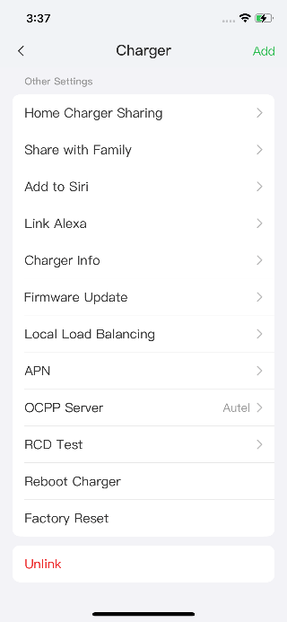 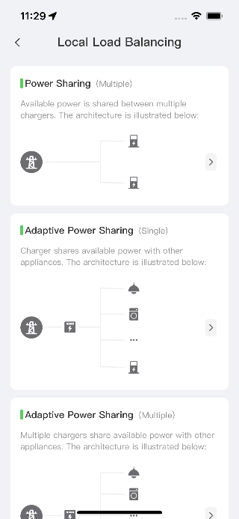 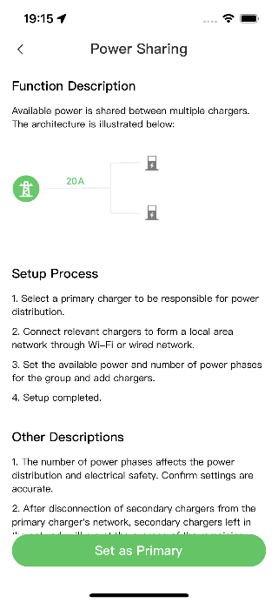

1. **Set up DLB mode.** After designating the primary charger, you must configure it for DLB mode.

* **Available Power (kW)**: you must enter the available power that the system can supply to the chargers. This value must be expressed as a whole number.

The value of the available power should be within the following range:

* Maximum Value: lower than upstream MCB/RCBO rated power.
* Minimum Value: higher than minimum power of one charger (1400 W for single-phase, 4200 W for three-phase) x N (N represents the number of chargers in the device group.)
* **Number of Phases**: select **Single-phase** or **Three-phase** based on your power supply mode.
* **Add secondary chargers**: tap **Add** to display other chargers connected to the same network. Tap **OK** once you have confirmed.

**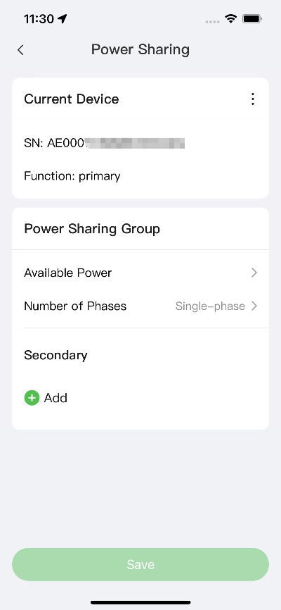 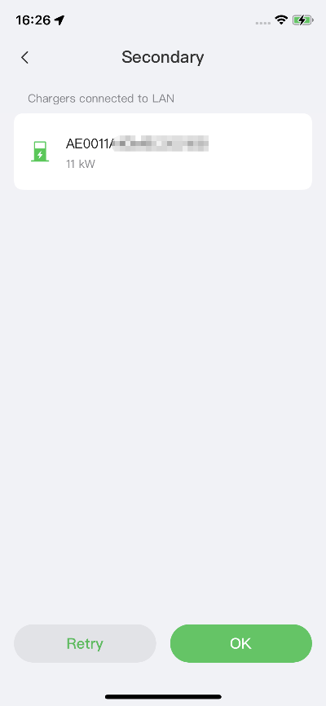**

1. **Confirm that the configuration was successful.** After all the settings above are completed, tap **Save** on the Power Sharing screen. The **Enabled** tag will appear on this mode, indicating that DLB mode is activated and your chargers can be charged according to your settings.

**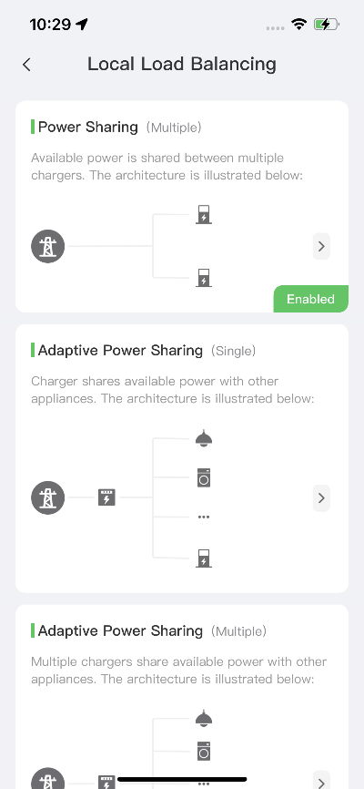**

# ALM Mode w/ Single Charger

ALM mode w/ single charger is suitable for cases where there is a single charger sharing power with other loads.

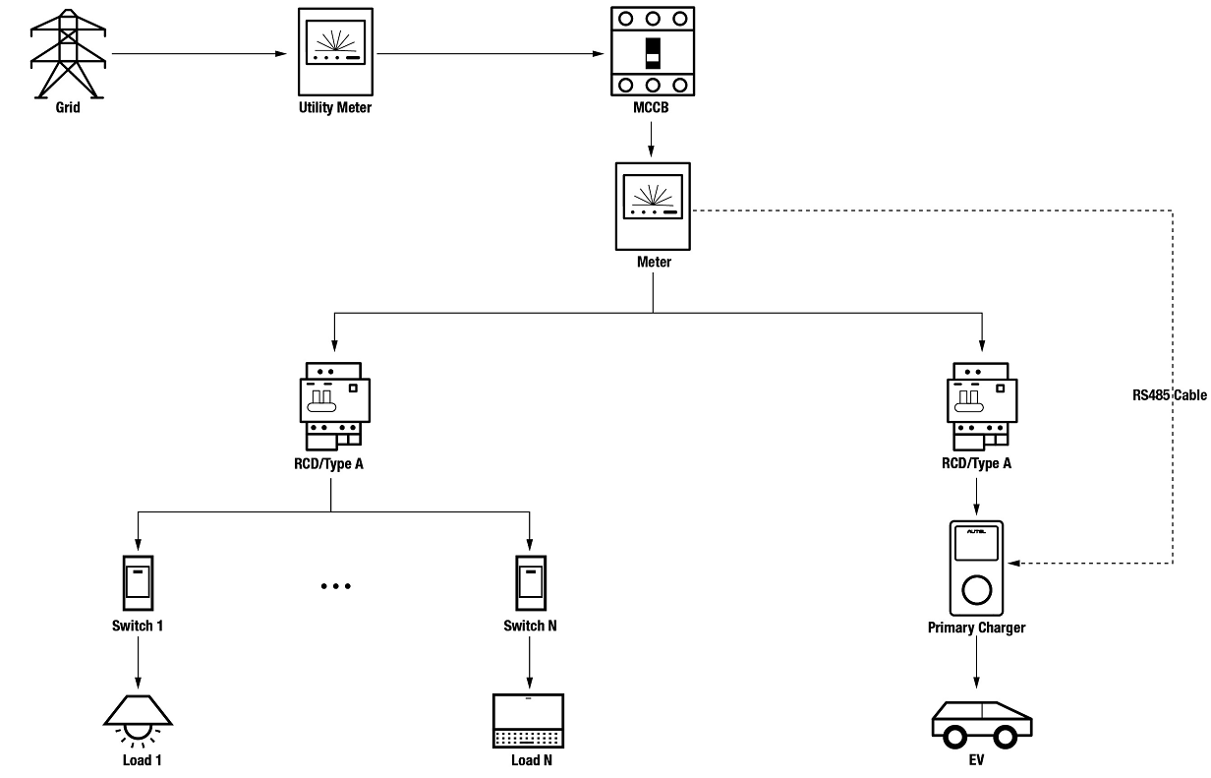

*ALM Mode System Diagram (w/ Single Charger)*

IMPORTANT

1. To comply with relevant electric leakage protection standards, please use at least a Type A RCD or an equivalent electrical leakage protector that complies with local standards.
2. Installation must be performed by qualified personnel in accordance with local regulations.

## Installation Guide

****

An RS485 cable is required for establishing a communication between the primary charger and the meter.

To save time in purchasing an appropriate energy meter, the recommended AC energy meters are listed below, which can be purchased from local distributors.

* Single-phase ≤ 100 A for EU market: SDM230-Modbus V1
* Single-phase ≤ 100 A for UK market: SDM230-Modbus V2
* Single-phase > 5 A, ≤ 9999 A: SDM120CTM
* Three-phase ≤ 100 A: SDM630-Modbus V2
* Three-phase > 100 A, ≤ 250 A: SDM630MCT V2

|  |
| --- |
| After the meter is properly installed and connected to upstream MCB/RCBO, wire an RS485 cable between the charger and meter.    ***SDM230-Modbus V1 Energy Meter and Autel Charger Wiring Diagram*** |

|  |
| --- |
| ***SDM230-Modbus V2 Energy Meter and Autel Charger Wiring Diagram***    ***SDM120CTM Energy Meter and Autel Charger Wiring Diagram*** |
| ***SDM630-Modbus V2 Energy Meter and Autel Charger Wiring Diagram***    ***SDM630MCT V2 Energy Meter and Autel Charger Wiring Diagram*** |
| **NOTE**   1. Always keep the power turned off during wiring. 2. Ground wiring is not necessary in many cases. Determine whether to ground according to the local regulations. The above diagrams are presented in the form of grounding. 3. The CT sensors should be grounded to local PE due to the need for surge current protection. 4. In order for the meter to measure data accurately, it needs to be configured correctly. Please refer to the meter’s user manual for configuration instructions. |

## Configuration

Follow the steps below to activate ALM mode w/ a single charger via the Autel Charge app once you have installed and wired all the units according to the system diagram.

1. **Download** the Autel Charge app.

**NOTE**

Make sure all Autel AC MaxiChargers and the Autel Charge app are running the latest software versions.

1. **Log in** to your Autel Charge app using your account and password, or register if you don’t yet have an Autel Charge account.

** **

1. **Add the charger.** After successfully logging in, tap **Add** to continue. Scan the QR code on the Quick Reference Guide to acquire the serial number and PIN of the charger, or tap **Enter Terminal Number** to manually enter the serial number and PIN. Tap **Link** after confirmation.

  

1. **Establish communication between the charger and the Autel Charge app.** After adding the charger, tap **Connect via Bluetooth** to establish communication and configure the Wi-Fi for the charger. Tap **Completed** on the Charge Settings screen to proceed.

  

1. **Set primary charger.** Tap **Account** ＞ **Charger** ＞ **Local Load Balancing**. Select **Adaptive Power Sharing (Single)**. A brief description about this mode will display on the screen. Tap **Set as Primary** to designate the charger as the primary charger.

  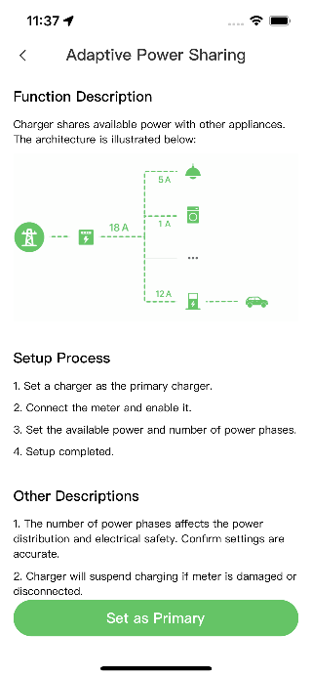

1. **Set up** **ALM mode w/ single charger.** After setting the primary charger, you need to complete the settings to set up ALM mode w/ single charger.

* **Smart Meter**:toggle the **Smart Meter** ON.
* **Available Power (kW)**: you need to enter the available power that the system can supply to the chargers. You must enter a whole number.

The value of the available power should be within the following range:

* Maximum Value: lower than upstream MCB/RCBO rated power.
* Minimum Value: higher than minimum power of one charger (1400 W for single-phase, 4200 W for three-phase) x N (N represents the number of chargers in the device group.)
* **Power Reserve**: you must enter the power reserve for the charger, namely the reserved power not used for charging.
* The range of the power reserve is from 0–50%. The maximum reserved power that can be entered is 50% of the total home power.
* The default setting of the power reserve is 10%, which is used for the dynamic power change caused by load switching in and out.
* **Number of Phases**: select **Single-phase** or **Three-phase** based on your power supply mode.

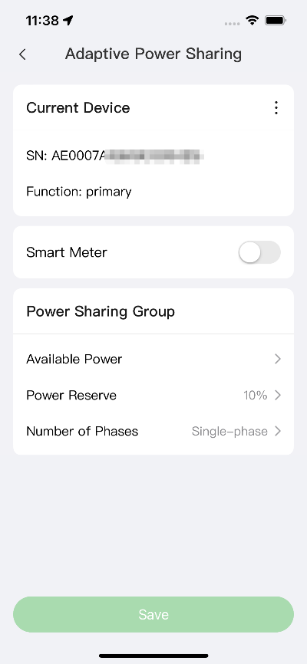

1. **Confirm that the configuration was successful.** After all the settings above are completed, tap **Save** on the Adaptive Power Sharing screen. The **Enabled** tag will appear on this mode, indicating that the ALM mode w/ single charger is activated and your charger can now be charged according to your settings.

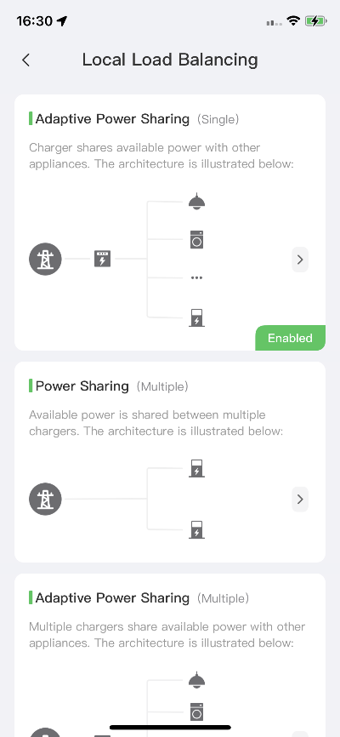

# ALM Mode w/ Multiple Chargers

ALM mode w/ multiple chargers is suitable for cases where there are multiple chargers sharing power with other loads.

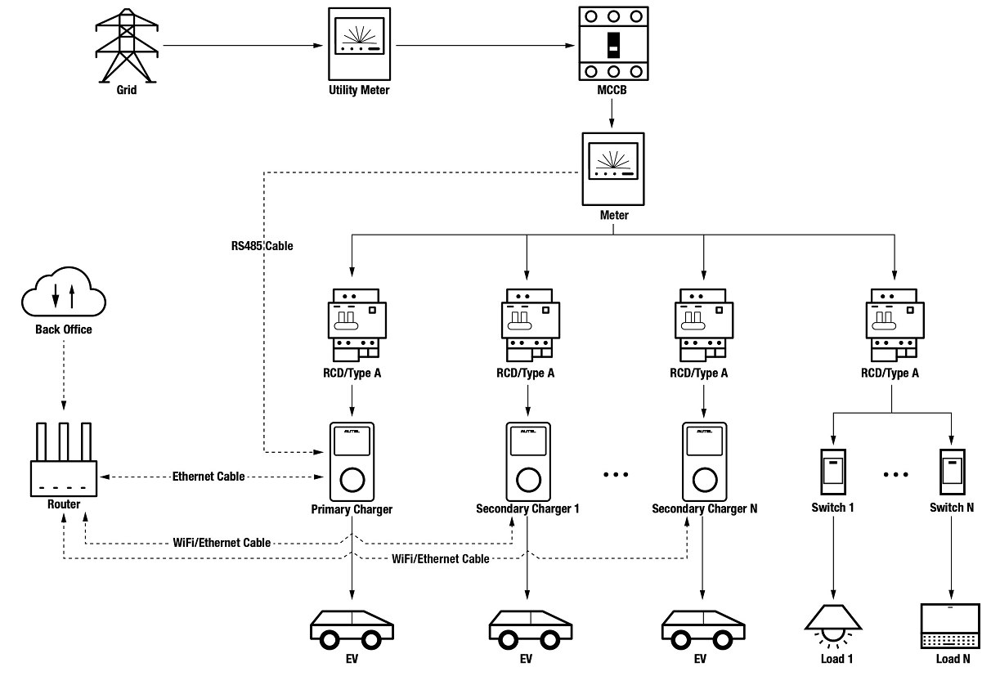

*ALM Mode System Diagram (w/ Multiple Chargers)*

IMPORTANT

1. To comply with relevant electric leakage protection standards, please use at least a Type A RCD or an equivalent electrical leakage protector that complies with local standards.
2. Installation must be performed by qualified personnel in accordance with local regulations.
3. All chargers connected using ALM mode must be of the same model. (8 chargers at most in this mode.)

## Installation Guide

****

The recommended meters and the RS485 cable wiring instructions are the same, so no details on that will be provided here. Refer to the RS485 cable wiring in *4.1*.

****

The Ethernet cable wiring is the same as that described in the previous chapter, so no details on that will be provided here. Refer to the Ethernet cable wiring in *3.1*.

## Configuration

Follow the steps below to activate ALM mode w/ multiple chargers via the Autel Charge app once you have installed and wired all the units according to the system diagram.

1. **Download** the Autel Charge app.

**NOTE**

Make sure all Autel AC MaxiChargers and the Autel Charge app are running the latest software versions.

1. **Log in** to your Autel Charge app using your account and password, or register if you don’t yet have an Autel Charge account.

** **

1. **Add a charger.** After successfully logging in, tap **Add** to continue. Scan the QR code on the Quick Reference Guide to acquire the serial number and PIN of the charger, or tap **Enter Terminal Number** to manually enter the serial number and PIN. Tap **Link** after confirmation.

  

1. **Establish communication between the charger and the Autel Charge app.** After adding the charger, if you define the charger as the primary charger, tap **Connect via Bluetooth** to establish communication,then connect it to a Wi-Fi network. Tap **Completed** on the Charge Settings screen to proceed.

  

1. **Add secondary chargers.** Tap **Add** on the upper-right corner in the following screen and follow **STEPS 3–4** to add more chargers and configure their Wi-Fi.

**NOTE**

1. Bluetooth can only be connected to one charger at one time. Switching the operation to another charger will disconnect the Bluetooth connection with the existing charger and connect it to a new charger. Therefore, if you define the charger as a secondary charger, you need to tap **Skip** on the Connect Charger via Bluetooth screen, and configure Wi-Fi directly.
2. All chargers added must be on the same Wi-Fi network.

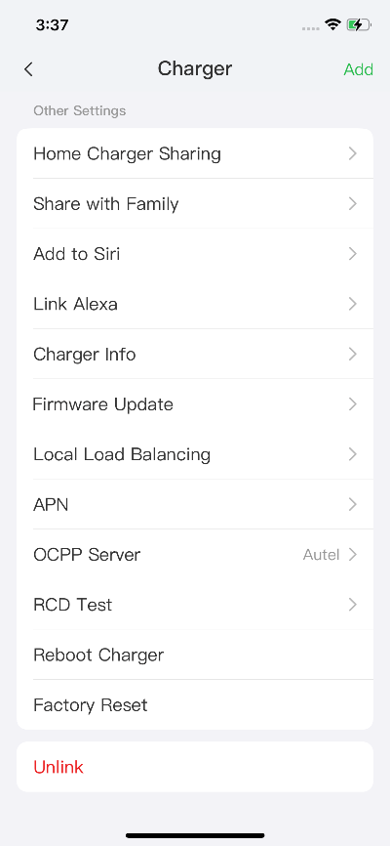

After adding chargers and configuring them to the same Wi-Fi network, you can check whether smart charging is enabled by observing the status of the Internet Connection Indicator.



*Internet Connection Indicator*

| **Indicator** | **Status** | **Description** |
| --- | --- | --- |
| **Internet Connection Indicator** | Steady On | Network connected;  Smart charging not enabled. |
| Steady Off | Network not connected. |
| Blink Fast | Smart charging enabled;  Connection NORMAL. |
| Blink Slow | Smart charging enabled;  Connection ABNORMAL. |

1. **Set primary charger.** Tap **Account** ＞ **Charger** ＞ **Local Load Balancing**. Select **Adaptive Power Sharing (Multiple)**. A brief description about this mode will display on the screen. Tap **Set as Primary** to set the charger as primary charger.

 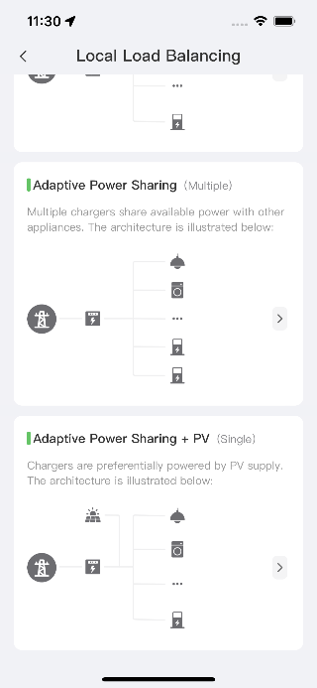 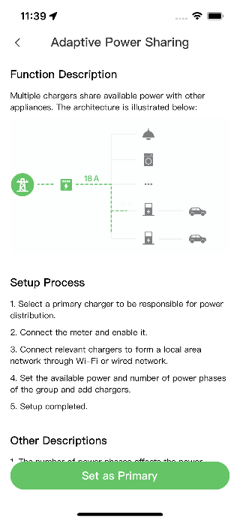

1. **Set up ALM mode w/ multiple chargers.** After designating the primary charger, you need to complete the settings to set up ALM mode w/ multiple chargers.

* **Smart Meter**:toggle the **Smart Meter** ON.
* **Available Power (kW)**: you need to enter the available power the system can supply to the chargers. You must enter a whole number.

The value of the available power should be within the following range:

* Maximum Value: lower than upstream MCB/RCBO rated power.
* Minimum Value: higher than minimum power of one charger (1400 W for single-phase, 4200 W for three-phase) x N (N represents the number of chargers in the device group.)

* **Power Reserve**: you must enter the power reserve for the chargers, namely the reserved power not used for charging.
* The range of the power reserve is from 0–50%. The maximum reserved power that can be entered is 50% of the total home power.
* The default setting of the power reserve is 10%, which is used for the dynamic power change caused by load switching in and out.
* **Number of Phases**: select **Single-phase** or **Three-phase** based on your power supply mode.
* **Add Secondary Chargers**: tap **Add** to display other chargers connected to the same network. Tap **OK** once you have confirmed.

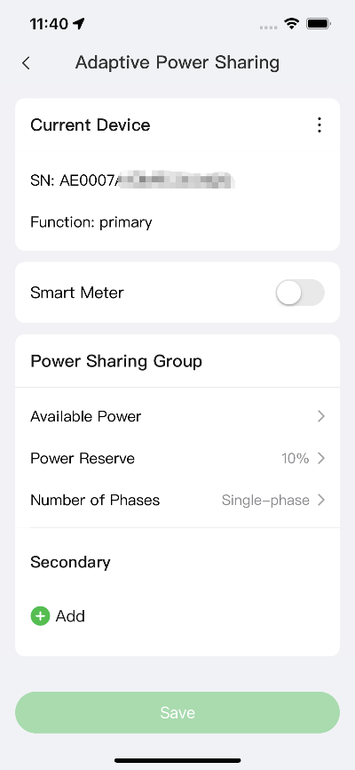  ****

1. **Confirm configuration.** After all the settings above are completed, tap **Save** on the Adaptive Power Sharing screen. The **Enabled** tag will appear on this mode, indicating that ALM mode w/ multiple chargers is activated and your chargers can now be charged according to your settings.

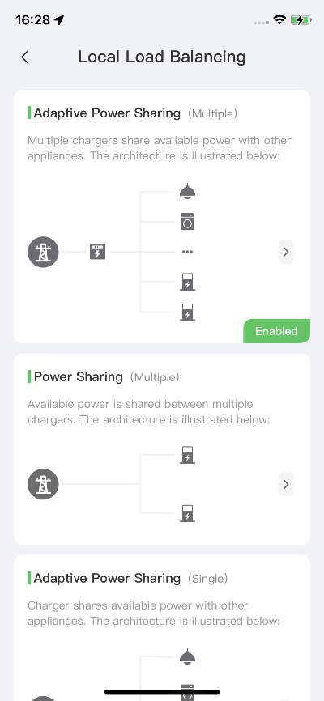

# PV Hybrid Mode

PV Hybrid mode is suitable for cases where solar energy and electricity are used at the same time, the solar energy is used preferentially to supply power.

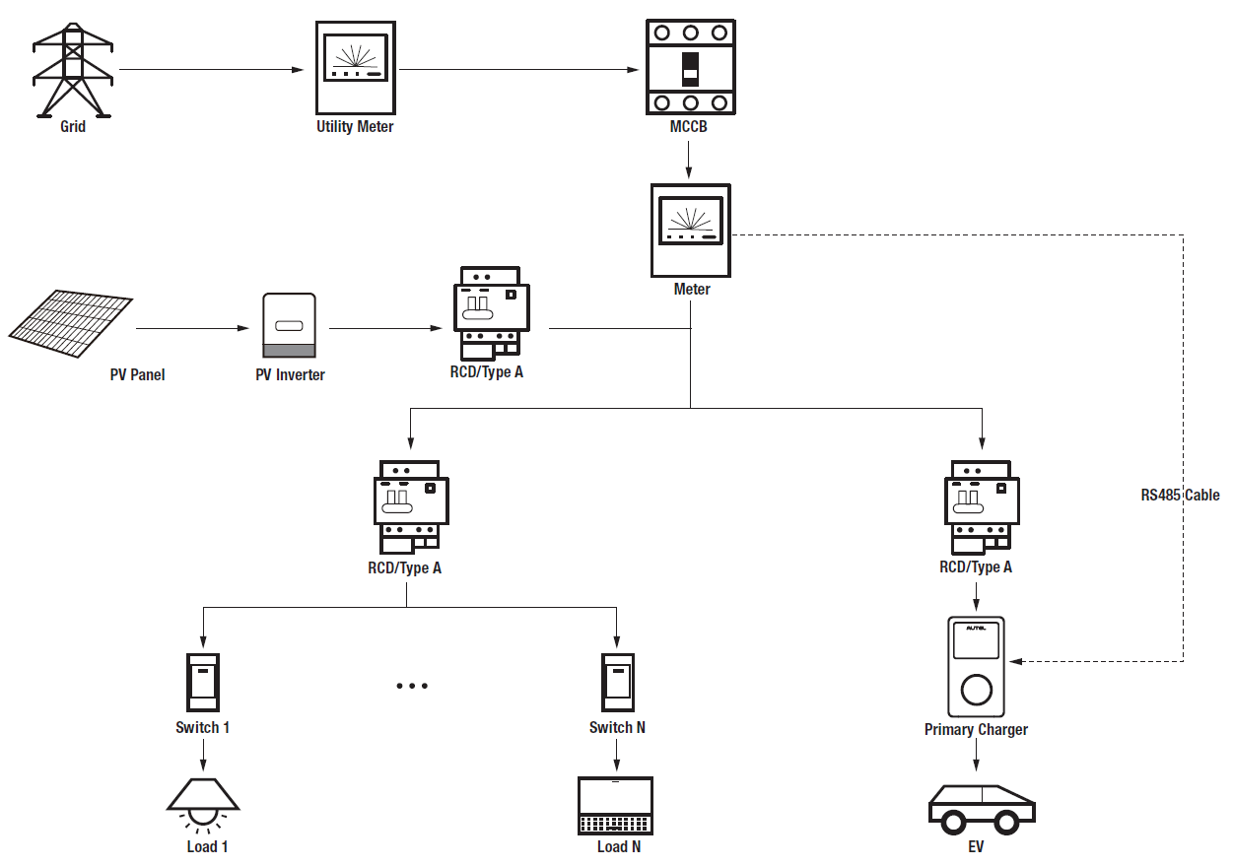

*PV Hybrid Mode System Diagram*

IMPORTANT

1. To comply with relevant electric leakage protection standards, please use at least a Type A RCDs or an equivalent electrical leakage protector that complies with local standards.
2. Installation must be performed by qualified personnel in accordance with local regulations.

## Installation Guide

****

The recommended meters and the RS485 cable wiring instructions are the same, so no details on that will be provided here. Refer to the RS485 cable wiring in *4.1*.

## Configuration

Follow the steps below to activate PV Hybrid mode via the Autel Charge app once you have installed and wired all the units according to the system diagram.

1. **Download** the Autel Charge app.

**NOTE**

Make sure all Autel AC MaxiChargers and the Autel Charge app are running the latest software versions.

1. **Log in** to your Autel Charge app using your account and password, or register if you don’t yet have an Autel Charge account.

** **

1. **Add the charger.** After successfully logging in, tap **Add** to continue. Scan the QR code on the Quick Reference Guide to acquire the serial number and PIN of the charger, or tap **Enter Terminal Number** to manually enter the serial number and PIN. Tap **Link** after confirmation.

  

1. **Establish communication between the charger and the Autel Charge app.** After adding the charger, tap **Connect via Bluetooth** to establish communication,then configure Wi-Fi for the charger. Tap **Completed** on the Charge Settings screen to proceed.

  

1. **Set primary charger.** Tap **Account** ＞ **Charger** ＞ **Local Load Balancing**. Select **Adaptive Power Sharing + PV (Single)**. A brief description about this mode will appear on the screen. Tap **Set as Primary** to designate the charger as the primary charger.

  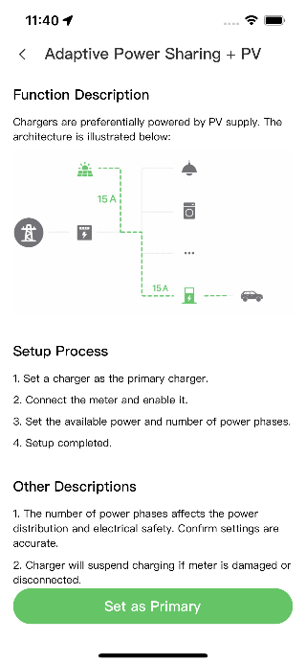

1. **Set up PV Hybrid mode.** After designating the primary charger, you need to complete the settings to configure PV Hybrid mode.

* **Smart Meter**:toggle the **Smart Meter** ON.
* **Available Power (kW)**: you need to enter the available power that the system can supply to the chargers. You must enter a whole number.

The value of the available power should be within the following range:

* Maximum Value: lower than upstream MCB/RCBO rated power.
* Minimum Value: higher than minimum power of one charger (1400 W for single-phase, 4200 W for three-phase) x N (N represents the number of chargers in the device group.)
* **Number of Phases**: select **Single-phase** or **Three-phase** based on your power supply mode.

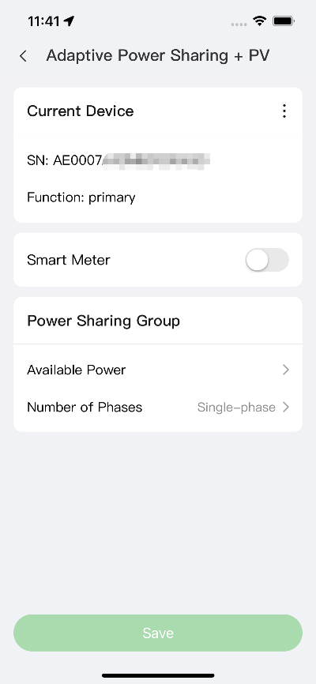

1. **Confirm configuration.** After all the settings above are completed, tap **Save** on the Adaptive Power Sharing + PV screen. The **Enabled** tag will appear on this mode, indicating that PV Hybrid mode is activated. Your charger can now be charged according to your settings.

**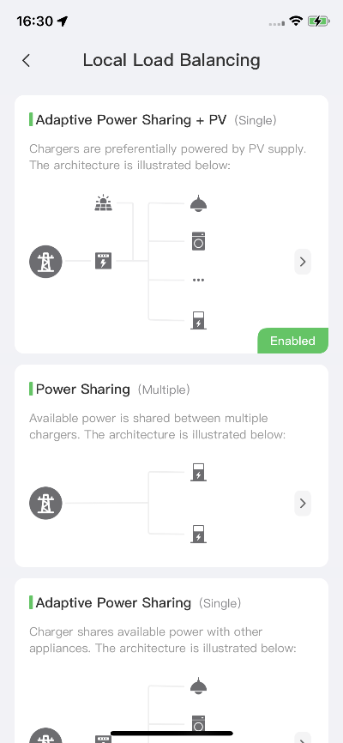**

# Energy Management System Strategies

Autel energy management system solution is developed through repeated configuration and verification. Below are the Autel energy management system strategies.

|  |
| --- |
| **DLB Mode**   * Reserved Power = Maximum Power Configured in DLB Setting / Number of Chargers Configured in the DLB System * Allocated Power for Each Offline Charger = Maximum Power Configured in DLB Setting / Number of Chargers Configured in the DLB System * Offline Power = Allocated Power for Each Offline Charger x Number of Offline Chargers * Allocated Power for Each Remaining Online Charger in Charging = (Maximum Power Configured in DLB Setting - Reserved Power - Offline Power) / Number of Online Chargers in Charging     **NOTE**  When all chargers are online and charging, the reserved power is 0. |

|  |
| --- |
| **ALM Mode**   * Allocable Power = Maximum Power Configured in ALM Setting x (1 - 5% - Reserved Power Percentage in the Charging Station in ALM Setting) * Offline Power = Minimum Charging Power for Charger x Number of Offline Chargers * Allocated Power for Each Online Charger in Charging = (Allocable Power - Household Loads - Offline Power) / Number of Online Chargers in Charging * Allocated Power for Each Offline Charger = Minimum Charging Power for Charger   **NOTE**   1. If the calculated online allocated power is lower than the minimum charging power, the last activated charger will pause charging and will resume charging when the online chargers can be charged using the minimum charging power. 2. If the meter is abnormal, all chargers will pause charging.   **Minimum Power**   1. When using a single-phase power supply, the minimum power is 1400 W. 2. When using a three-phase power supply, the minimum power is 4200 W. |

|  |
| --- |
| **PV Hybrid Mode**   * **When** Solar Energy ＞ Household Loads + Minimum Charging Power for Charger,   the **Allocated Power** = Solar Energy - Household Loads.   * **When** Solar Energy ≤ Household Loads + Minimum Charging Power for Charger,   the **Allocated Power** = Minimum Charging Power for Charger.    **NOTE**  In PV Hybrid mode, only one charger is supported for charging. |



**Autel Digital Power Co., Ltd.**

Website: [www.autelenergy.eu](file:///C:\Users\A21905\Desktop\www.autelenergy.eu)

Phone: +49(0)89 540299608 (Monday–Friday, 9:00 AM–6:00 PM Berlin Time)

Address: Landsberger Str. 408, 4. OG, 81241 Munich, Germany